|  |
| --- |
| UNC Charlotte - MakerSpace |
| Raspberry Pi |
| Basic Setup Guide |

|  |
| --- |
| Dinesh Auti  5-1-2017 |

**What is a Raspberry Pi?**

The Raspberry Pi is a credit-card-sized computer that plugs into your TV and a keyboard. It is a capable little computer which can be used in electronics projects, and for many of the things that your desktop PC does, like spreadsheets, word processing, browsing the internet, and playing games. It also plays high-definition video.

**Parts**

Make sure you have the followings parts before you proceed:

* Raspberry Pi Model 3 (the one with wireless capabilities)
* Micro USB cable (for power)
* 8 GB microSD Card
* An SD Card reader for a Desktop or a laptop with a SD card slot
* LAN cable (needed for initial setup)

*NOTE: If you plan to use the Raspberry Pi’s from the Makerspace, then the initial setup has already been done. Just start playing* ☺

**Setup**

The following sections describe how to setup the Raspberry Pi for the first time.

**Step 1: Downloads**

You need to download a few software’s and an Operating System to start. Below is the list:

* [Raspbian Jessi](https://www.raspberrypi.org/downloads/raspbian/) - Operating System
* [SD card Formatter](https://www.sdcard.org/downloads/formatter_4/eula_windows/index.html) - Format SD card so that we can burn the new image (MAC and Windows)
* [Win32 Disk Imager](https://sourceforge.net/projects/win32diskimager/) - Software to burn the image into the SD card (In case of MAC, drag and drop the contents into the SD Card)
* [Putty](http://www.chiark.greenend.org.uk/~sgtatham/putty/download.html) - SSH client for Windows. In the case of MAC and Linux, you can directly SSH from the terminal.
* [Advanced IP Scanner](http://www.advanced-ip-scanner.com/download.php?lng=en) (Windows), [Angry IP Scanner](http://angryip.org/download/#windows) (MAC and Linux)

**Step 2: Prepare the SD Card**

Why do you need the SD Card?

The Raspberry Pi as such does not have any dedicated Hard-Drive (HDD) to store its operating system. To do so, we need the SD Card, which acts as the secondary storage drive.

*NOTE: The Raspberry Pi does have an onboard 1 GB of RAM.*

Plug in the SD card into your Laptop (or feel free to use one of the Desktop’s in the Makerspace) using the [adapter](https://cdn-shop.adafruit.com/1200x900/1121-03.jpg) or use an SD card reader.

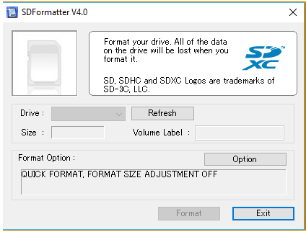

Format the card using the SD card formatter. Be extremely careful to select the correct drive!

Once that is done, open the Win32 Disk Imager and select the SD card drive and the ISO image to burn.

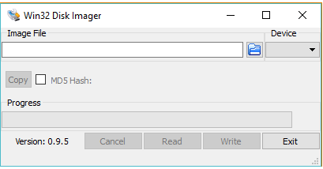

This will take a while to burn the image. Once completed remove the SD card.

**Step 3: Connect Cables**

Connect the cables (power and LAN) to the Raspberry Pi; they only connect to the correct holes.

Insert the SD card. The SD card only fits the slot the correct way. The SD card slot is on the other side of the USB ports.

Finally, connect the micro USB cable between the Raspberry Pi and a power source. Raspberry Pi requires about 1 Watt of power. So, a good quality, powerful USB charger like a Nexus 5 charger is a good choice.

A red PWR (power) LED lights up to indicate that the device has booted normally. If this is not the case, check the power cable again.

**Step 4: SSH**

[Secure Shell](https://www.digitalocean.com/community/tutorials/ssh-essentials-working-with-ssh-servers-clients-and-keys) (SSH) is a cryptographic network protocol for secure data communication, remote command-line login, remote command execution, and other secure network services between two networked computers.

In simple terms, SSH will allow you to connect with the Raspberry Pi using the [terminal](https://www.digitalocean.com/community/tutorials/an-introduction-to-the-linux-terminal) (command line interface).

*NOTE: The latest Raspbian image has a default configuration with SSH enabled.*

Below is a step by step guide for establishing an SSH connection from your machine (Windows/MAC/Linux) to the Raspberry Pi.

* Download Putty (refer to the link given in the Downloads section). Click on the first option (putty.exe - refer the image shown below). Open the downloaded program.

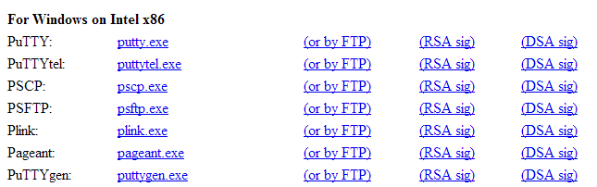

* Next, find the IP address of the Raspberry Pi. For this install the Advanced IP Scanner (Windows) or Angry IP Scanner (MAC & Linux). Launch it & click the play button (green arrow). It will list out all the IP’s on your home network. On the right side, you will find the device name, search for Raspberry Pi Foundation. Make a note of the IP for that name. To make this easy, connect only one Raspberry Pi at a time so that there is no confusion as to which IP belongs to which Raspberry Pi.

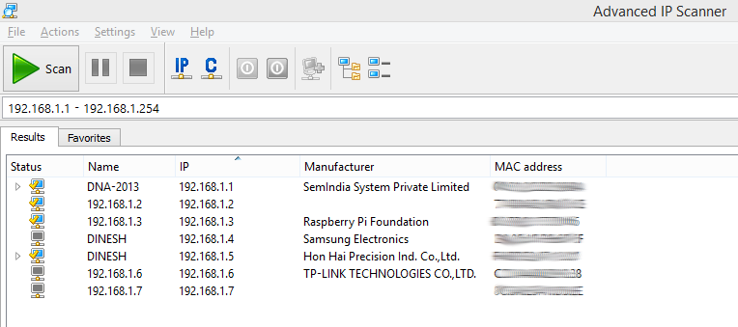

Note: In case of Angry IP scanner make sure that the IP range corresponds to 192.168.1.0 – 192.168.1.255

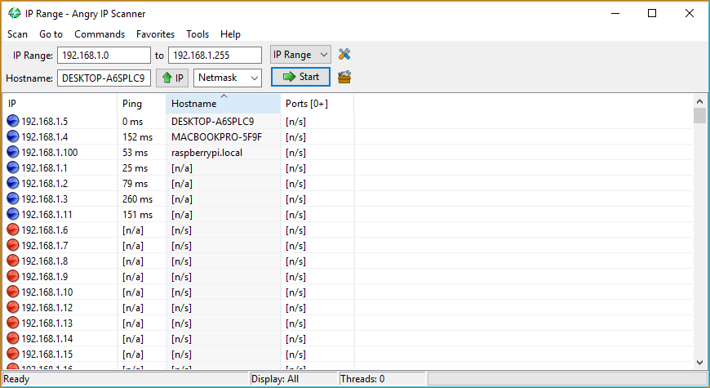

* One more step to go. In case of windows, open Putty and type the IP address in the Hostname dialogue box as shown below:

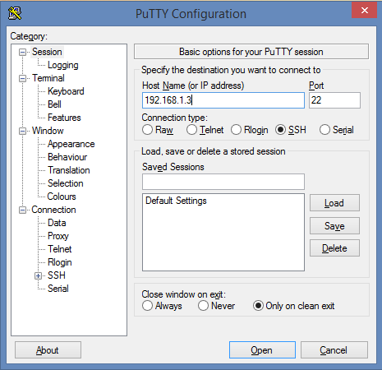

* Click Open. This will open a connection to the Raspberry Pi. And a command window will pop up asking you to enter login & password. The default login is “pi” & password is “raspberry” for the Raspbian OS.

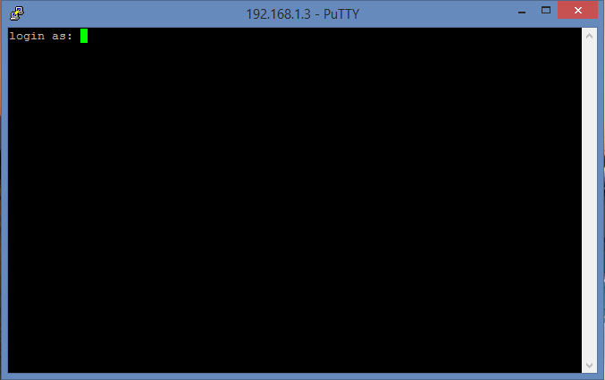

Once you enter the password, you will be given access to Pi’s shell window. Using this method, you won’t be able to see the desktop, only the command line will be available.

For MAC and Linux users, type the below command in the terminal to SSH into the Pi.  
  
ssh pi@192.168.1.100

Make sure to change the IP address to your Pi’s IP.

You have successfully logged into the Pi!

**Step 5: Graphical User Interface (GUI) Desktop**

It is difficult for a beginner to get started with the command line interface. So, a much more comfortable and user friendly way is to use a Graphical User Interface. We will accomplish this using the VNC server - client setup.

Since we have a command line access to Pi, we can install any software using the command sudo apt-get install. Using this to our advantage, let’s start by installing VNC server (I am assuming, Pi has access to the internet). To do so run the following command:

sudo apt-get install tightvncserver

During installation, you will be prompted to install without verification, Press “y”. Until this point, we have only installed the VNC server, but not yet started it. Run the following command to start the server:

vncserver :1 // 1 is the display#

I have used the most basic form of the command. You can customize it as per your requirement, here is the [link](https://archive.realvnc.com/products/vnc/documentation/4.2/unix/man/vncserver.html). An example would look like

vncserver :1 -geometry 1200x800 -depth 16 -pixelformat rgb565

This command will start a VNC process on the Pi. In simple words, it will start a GUI instance of your Pi. That is same as startx, which is used when you connect your Pi to a display.

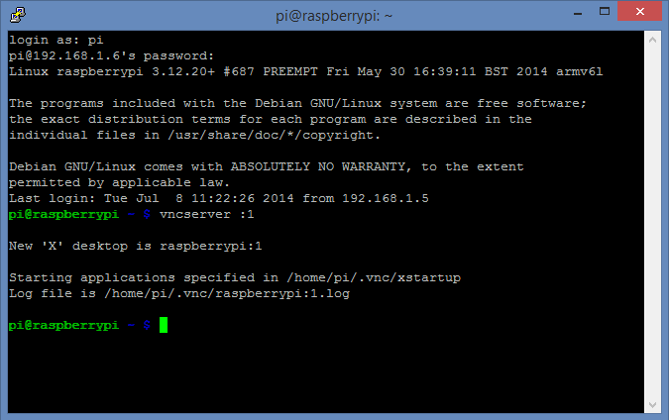

The main part of the command is display#, which is 1 in our case. This is just a random number that I chose, you can choose any other number of your choice. This defines the port on which the VNC process will be started. So, the next time you need to connect you will need this number. Better, remember it.

When you start the VNC server for the first time, you will be prompted for a password. This will be used later when you try to connect to Pi from your PC. The part related to Pi is over; now we move over to the PC side installation.

A VNC viewer (client) is required to access the GUI from a remote machine. Instead of downloading a separate viewer, we will be using the Chrome add-on extension “VNC Viewer for Google Chrome” – Since this is a part of Google Chrome, it’s platform independent. Go to the Chrome store and add it your list of apps.

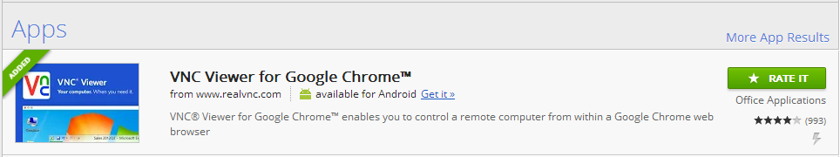

Once you start the app, you will be greeted with the below screen



In the space provided enter the IP address of your Pi and the display number in the format shown in the figure above. Click on Connect.

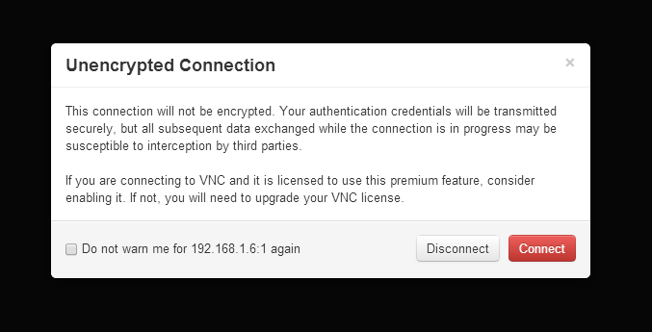

Check the box “Do not warn me”. Click on connect.

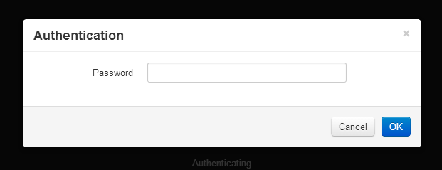

This is the same password that you had set during the VNC server installation on Pi. Enter it & you will be greeted by raspberry pi’s desktop.

